

**BORDER LAND SCHOOL DIVISION**

Student Services

120 9th Street NW Altona MB R0G 0B1

Phone: 204-324-6491 Website: www.blsd.ca

October 2021

**Dear Parents,**

In the last year and a half, we’ve all had to make many changes in the way we do things. Some of these changes have meant that fewer parents/families are out and about and doing things they enjoy – like participating in community events and visiting their children’s schools.

In spite of all these changes, BLSD Student Services staff members want to stay connected with families and to support them as much as is possible in these times. This monthly newsletter is one way for that connection to happen.

In each newsletter, you will find items that include at least a little of the following information:

Learning/Education Healthy Living Parenting

Although the newsletters are written for families with young children, we think you will find ideas and information that relate to your whole family. Feel free to take pictures of you and your children as you use the ideas, send them to us, and we will post some of the photos we receive to our BLSD website!

(email to Leila Carr at [CarrL@blsd.ca](mailto:CarrL@blsd.ca)) **and...ENJOY!**

**Some Tasty Snack Ideas**

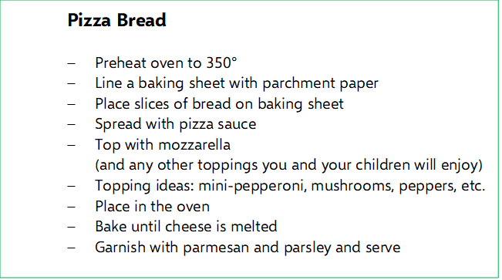

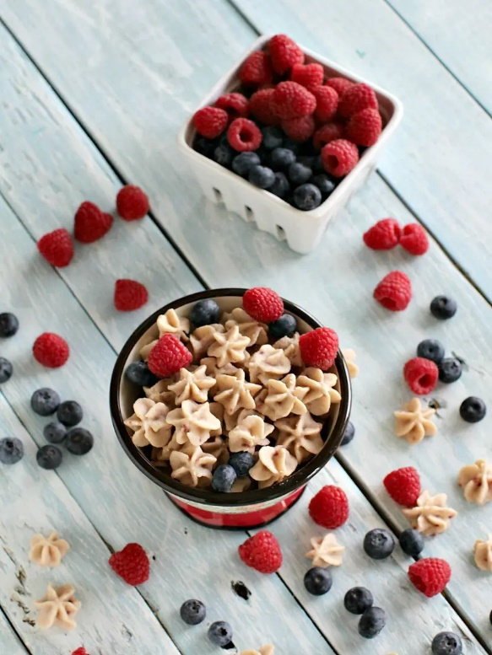

**Fro-Yo Fruit Bites**

INGREDIENTS:

1 1/2 c. plain yogurt

1/4 c. whole milk

2 tsp. honey

1/2 tsp. pure vanilla extract

1/2 c. blueberries

1/2 c. strawberries, quartered

1/2 c. raspberries

**Communication Cues**

DIRECTIONS:

1. Combine yogurt, milk, honey and vanilla
2. Whisk until smooth
3. In an ice tray, distribute fruit in each of the cube molds
4. Spoon yogurt mixture over fruit, filling molds completely
5. Freeze for 5 hours, or until frozen solid

Talking with your child is important. It shows you care about them, and you’re interested in their life.

**BUT**…does your child shrug their shoulders or answer “fine” when you ask them about their time at daycare, at their grandparents’, or at school? Here are some tips that may help!

**Pick a good time to talk and ask questions.**

**Remember…Simple, Positive, and Specific!**

· **Take advantage of regular moments** you do have together, like car rides, walking to school in the morning and bedtime for casual, low-pressure chats.

· **Consider** **sharing a few details from your own day** to encourage conversation—it shouldn’t feel like a one-sided interrogation. This also teaches kids that everyone has good days and bad days, no matter how old you are.

When did you laugh today?

Who did you play with today?

What did you like better today… Snack time or circle time?

What was fun today?

**Reconnect by being present.**

**What are you noticing? What do you wonder?**

When I picked you up, you had a funny face. What happened?

Contribution by:

Ms. Stephanie DeGroot

(Gretna Elementary School)

You smile when you talk about ___. Tell me more about that!

**Two Activities – Scavenger Hunt & Crafting**

Here are two activities that can go hand-in-hand…

**Activity #1**: Do a Scavenger Hunt outside (anywhere) with your children.

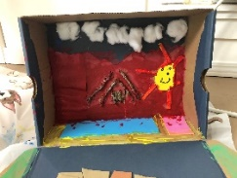

|  |
| --- |
| **To find…**  pinecone acorn feather leaf twig  **To look for…**  cloud spider web leaf falling to the ground a bug  **To smell…**  cedar woodsmoke wet leaves  **To listen for…**  birds singing leaves crunching under your feet wind in the trees squirrels  **To feel…**  tree bark sun on your face wind on your face smooth rock |

**Activity #2:** Assemble found treasures into a ‘project’!

**TRY THIS:** Don’t tell them what to make…

You’ll be surprised at how creative they can be if you

encourage them to come up with their own ideas!